Fast Fashion and its Effects

on the Environment

Jaiden Neff

ENG371-01 White Paper

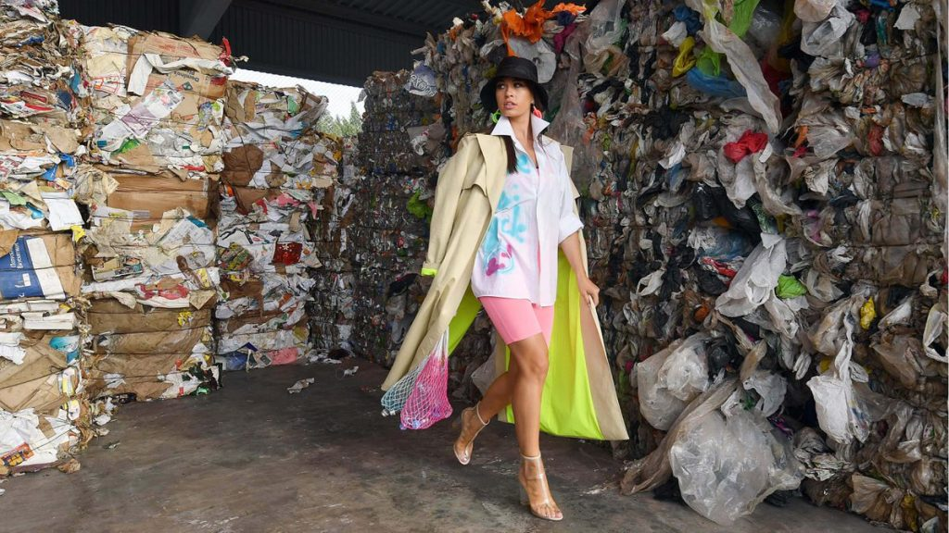

Source: <https://blog.remoovit.com/2022/03/02/how-to-quit-fast-fashion-for-good/>

Table of Contents

Introduction 3

Background 3

Clothing Waste and Pollution 4

The Increase of Fast Fashion 5

Ways to Reduce our Clothing Carbon Footprint 6 Conclusion 7

Resources 8

Introduction

The world of fashion is one that is ever changing and is looked at as extremely important to our culture by most. This world however is tainted by the introduction of a phenomenon notoriously named “fast fashion.” Fast Fashion is defined as “cheaply produced and priced garments that copy the latest catwalk styles and get pumped quickly through stores in order to maximize on current trends.” (Earth.Org.) This phenomenon has been sweeping the nation with companies like H&M, Shien, Zara, and even GAP using fast fashion techniques to produce the most current trends at a fraction of the price of designer brands. This targets the demographic of teen and college students who are on a budget and wanting to stay with the fashion of the times. What they don’t tell you however is the extreme environmental impacts that fast fashion has on the world and the extreme increase in clothing waste we have acquired over the bast twenty to thirty years.

Background

Fast fashion has been a growing issue not only in the US but all over the world since the early 2000’s. Companies realized that they could produce clothing at half the cost and sell it for cheap to the younger generations who are always wanting to improve and take their fashion to the next level. Zara was one of the first companies to really come off the ground with fast fashion in the 1990s. The New York Times coined the phrase because of Zara’s mission to take only fifteen days to go from the design stage to being sold in stores. From here it kind of took off with other companies applying the same practices and using this cheap overseas labor to benefit themselves financially. As shown in the graphic below the amount of times clothing is worn vs clothing sales has decreased and increased immensely. Because of fast fashion people are beginning to buy more clothing and wear it less. The cheap garments also are more likely to rip and are made of more unrecyclable materials. This method of shopping might be good for your closet and selection and bank account but it’s really bad for the environment.

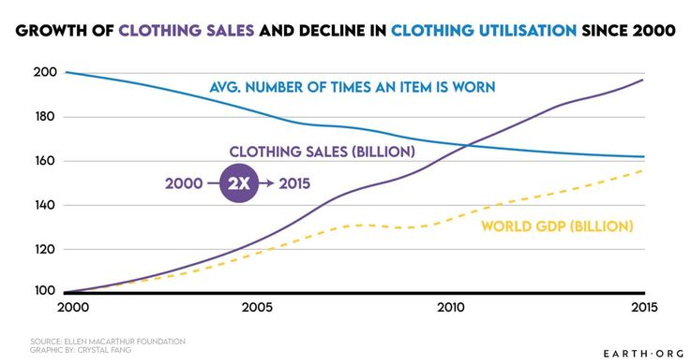

Clothing Waste and Pollution

There are a few reasons that fast fashion is extremely harmful. First and foremost, fast fashion uses sweatshops. Sweatshops are factors usually overseas in poorer countries where they use child labor and extreme hours for very little pay to produce clothing. This create horrible working conditions for the people who work in them and is the reason companies are able to market their clothing at such a cheap price. Beyond just the moral issue of sweatshops these factories produce tons of pollution and release it into the environment. Another issue that fast fashion crates is water and other natural resources. According to Wrap UK it takes around 1,800 gallons of water to make a single pair of jeans. The bigger issue that has come to light with the increase of fast fashion is the immense amount of clothing waste it creates. Every year, people in the United States throw out more than 34 billion pounds of used textiles. Divided across the population, that’s more than 100 pounds of textile waste per person each year (Boston University School of Public Health). Every year we produce up to 100 billion garments. With fast fashion it makes it that much easier to just throw away a cheap article of clothing if you aren’t “feeling it” anymore. The biggest problem this produces is that fashion cycles are moving a lot quicker. With higher demand and production, we can get bored of items just as fast as they come into fashion. This leads to the clothing we bought just last summer being so past being in fashion that its almost “unwearable”.

The Increase of Fast Fashion

As was previously stated, Fast Fashion has been shown to increase immensely as the years have gone on. However, during the year 2020 with the pandemic came the popularization of a clothing site called Shein. This company is based out of Singapore and has had one of the largest spikes ever seen in fashion. A University of Delaware textiles professor was quoted saying “Two years ago, three years ago, nobody had ever heard of them.” Now Shein has claimed the second-place spot only behind Amazon in a survey asking what teens favorite eCommerce site was. According to wired In April, Shein reportedly raised $1 billion to $2 billion in private funding. The company was valued at $100 billion which is higher than the combined worth of fast-fashion titans H&M and Zara, and higher than that of any private company in the world besides SpaceX and Byte-Dance, the owner of TikTok. These numbers are not only impressive but extremely scary for our future. If Shein and other brands of the same nature continue to increase in the way, they are it is feared that the environmental impact will be devastating and lasting. It is said that in the year 2030 we will see an increase that will double that of the pervious spike.

Ways to Reduce our Clothing Carbon Footprint

When looking into ways that we can decrease the clothing waste that is produced by fast fashion the answer might seem simple. Just stop buying from these companies which is a great goal to have personally, However, it’s not so simple. These companies work on such a mass scale that its very difficult to shut them down. Spreading the word and awareness is a good way to help reducing the clothing waste. Informing people about the harmful effects of fast fashion and trying our best to get people to understand the environmental impact. As stated before a personal goal could be not buying from these brands. Even though this doesn’t stop the problem if everyone made the personal decision to not buy from these companies it would make a world of a difference. To follow up on that point shopping sustainably is always a good way to be conscious of your clothing. High quality garments will last longer and reduce your carbon footprint. AnDonating clothing when you are done with it is a great way to help the recycling problem that comes with clothing.

Conclusion

Fast Fashion has been a growing problem in this country for some time now. Big companies like Zara and Shein are taking over the fashion industry in a way that is not sustainable or ethical. Because of Fast Fashions quick rise and good marketing, the problem is worse than it’s ever been and its projected to only get worse. We clothing we throw away ranges in the hundreds of millions. We need to do something to protect our earth and slow down the spread of fast fashion. If we don’t the number of clothes that end up in landfills is supposed to double by 2030. The toxic smog from the factories, the resources wasted, and the endless water waste is going to be unmatched in its devastation. We as consumers need to shop more sustainably, inform other of the environmental impacts, and recycle our clothing. This is the only way that we will have a chance to slow down the tycoon that is Fast Fashion.

Work Cited

Boston University School of Public Health. "The Aftermath of Fast Fashion: How Discarded Clothes Impact Public Health and the Environment." Boston University School of Public Health, 26 Jan. 2022, <https://www.bu.edu/sph/news/articles/2022/the-aftermath-of-fast-fashion-how-discarded-clothes-impact-public-health-and-the-environment/>.

Earth.Org. "Fast Fashion's Detrimental Effect on the Environment." Earth.Org, Earth.Org, 13 May 2021, <https://earth.org/fast-fashions-detrimental-effect-on-the-environment/#:~:text=The%20Dark%20Side%20of%20Fast%20Fashion&text=It%20dries%20up%20water%20sources,of%2050%20billion%20plastic%20bottles>.

Good On You. "What Is Fast Fashion?" Good On You, Good On You, 10 Sept. 2020, <https://goodonyou.eco/what-is-fast-fashion/>.

Keep Britain Tidy. "Waste Less, Live More: Slow Down Fast Fashion." Keep Britain Tidy, Keep Britain Tidy, 10 Sept. 2015, <https://www.keepbritaintidy.org/news/waste-less-live-more-slow-down-fast-fashion>.

Sandin, Gustav, et al. "Circular fashion supply chain design: A review." Sustainable Production and Consumption, vol. 22, 2020, pp. 21-38, <https://www.nature.com/articles/s43017-020-0039-9>.

Gwozdz, Wencke, et al. "Fast Fashion, Sustainability, and the Ethical Appeal of Luxury Brands." Management Science, vol. 67, no. 7, 2021, pp. 3497-3516, <https://pubsonline.informs.org/doi/abs/10.1287/msom.2021.1054>